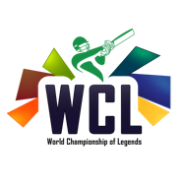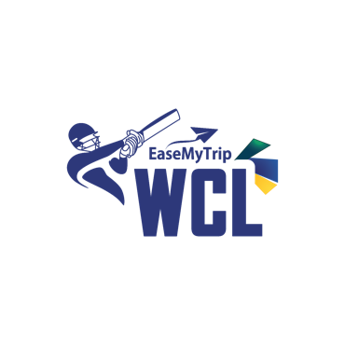
EaseMyTrip Announced as Presenting Partner of World Championship of Legends
New Delhi, April 30, 2024– EaseMyTrip, one of India's largest online travel platforms, announces its partnership as the presenting partner of the prestigious World Championship of Legends (WCL). This collaboration marks a significant milestone in the world of sports and entertainment, uniting two influential entities to enhance the cricketing experience for fans worldwide.

The World Championship of Legends is known for its outstanding contributions to cricket, and with EaseMyTrip as its presenting partner, the league is poised for further global recognition and engagement.

Nishant Pitti, CEO and Co-founder of EaseMyTrip shared his thoughts about the partnership, stating, "We are excited to serve as the presenting partner of the World Championship of Legends. This partnership underscores our unwavering dedication to championing sporting excellence and curating unforgettable experiences for cricket enthusiasts around the globe."

Bollywood actor Ajay Devgn, who has also invested in the World Championship of Legends, expressed his support, saying, "I welcome EaseMyTrip as the main presenters of the World Championship of Legends and am happy that we are on a path of creating new entertaining moments with our legendary cricketing heroes."

Harshit Tomar, the visionary founder and CEO of the World Championship of Legends, emphasized the significance of this partnership, stating, "EaseMyTrip is the second-largest travel company in India and from cricket to tennis to kabaddi, EaseMyTrip has been associated with numerous sports leagues.
I am confident that with EaseMyTrip on board, WCL will significantly strengthen"

Suresh Raina, a cricketing icon and valued member of the World Championship of Legends, expressed his enthusiasm, stating, "I'm thrilled to join India Champions in WCL! With EaseMyTrip as the powered by sponsors, the foundation of WCL is stronger than ever. Can't wait to get back on the field alongside other cricketing legends and compete at Edgbaston. See you all there!"

Harbhajan Singh, another revered figure in cricket, echoed Raina's sentiment, saying, "I am excited to join Indian Champions in WCL. Things are going in perfect direction , Getting ECB approval, huge response for ticket sales and now getting respected brands as sponsors. It strengthens the structure of WCL.”

The World Championship of Legends kicks off on the 3rd of July at the iconic Edgbaston Stadium in Birmingham, UK. Six teams will be vying for glory, including India Champions, Australia Champions, Pakistan Champions, England Champions, South Africa Champions, and West Indies Champions.
Legendary players such as Yuvraj Singh, Shahid Afridi, Brett Lee, Ian Bell, and Daren Sammy will grace the field, adding to the excitement and prestige of the tournament.

With EaseMyTrip as the presenting partner and the shared excitement of cricketing legends and investors, the World Championship of Legends is set to captivate audiences and solidify its position as a premier cricketing event.

About WCL
WCL is a premier cricket league approved by the England and Wales Cricket Board, featuring teams from 6 countries – India , Pakistan , England , West Indies , South Africa & Australia. The league is hosted at the prestigious Edgbaston ground in Birmingham.

About EaseMyTrip
EaseMyTrip (a public listed company at NSE and BSE) is India’s one of largest online travel platform in terms of air ticket bookings, based on the Crisil Report-Assessment of the OTA Industry in India, February 2021. Furthermore, growing at a CAGR of 59% during FY20-23 in profits, it is one of the fastest-growing internet companies. Bootstrapped and profitable since its inception, EaseMyTrip offers 'End to End' travel solutions including air tickets, hotels and holiday packages, rail & bus tickets as well as ancillary value-added services. EaseMyTrip offers its users the option of zero-convenience fees during bookings. EaseMyTrip provides its users with access to more than 400 international and domestic airlines, over 2+ million hotels as well as train/bus tickets and taxi rentals for major cities in India. Founded in 2008, EaseMyTrip has offices across various Indian cities, including Noida, Delhi and Gurugram, Bengaluru, and Mumbai. Its international offices (as subsidiary companies) are in the Philippines, Singapore, Thailand, the UAE, the UK, the USA and New Zealand.

For Media Queries:

EaseMyTrip Public Relations
Ms. Bhavika Sharma
bhavika.sharma@easemytrip.com
+91 98117 87304

